hendra anggrian
CELL (+62) 8788-1366177 • E-MAIL hendraanggrian@gmail.com • WEB hendraanggrian.github.io
PROFILE Full Name : Hendra Anggrianto Wijaya
Nickname : Hendra
Place, Date of Birth : Jakarta, 20 May 1992
Age : 23
Sex : Male
Nationality : Indonesia
SKILLS Languages
Mastered : Java, C#, XML, HTML, Javascript, JSON, SQL, SQLite, NoSQL
Yet to be : C, C++, Objective-C, Erlang
Not to be : PHP along with other Web Technologies

Platform
Android, Swing, JavaFX, dotNET Framework, Microsoft SQL, MySQL, BaasBox
EDUCATION Bachelor of Computer Science
Bina Nusantara International University
Jakarta, Indonesia
Graduated 2015

Diploma of Chinese Language and Culture
South China Normal University
Guangzhou, China
Graduated 2011
CERTIFICATION Microsoft Windows 8 Hackaton candidate (2012)

9th INAICTA (Indonesian ICT Award) nominee (2015)
EXPERIENCE MALIFAX TECHNOLOGIES (S) PTE LTD
Senior Android Developer (Dec 2015 – Current)
Started collaborating with graphic designers to enhance UI/UX. Has been given more resources to continue write native applications. Stopped maintaining databases and other back-end operations to focus on front-end development.
SIMPLIFY-INC (PT. Simpling Tri Jaya) / Prodigy Infinitech
Android Developer (Mar 2014 – Dec 2015)
Started writing native Android and .NET applications with limited resources. Also managed multiple databases and database connections. Eventually resigned due to conflict of interests.
PROJECTS Sing Downloader
An app built exclusively to download, play, and manage songs from SMULE, the biggest music-based social media. The app works by striping down the entire HTML source code, even ones generated by javascript.
https://play.google.com/store/apps/details?id=sg.com.malifax.singdownloader
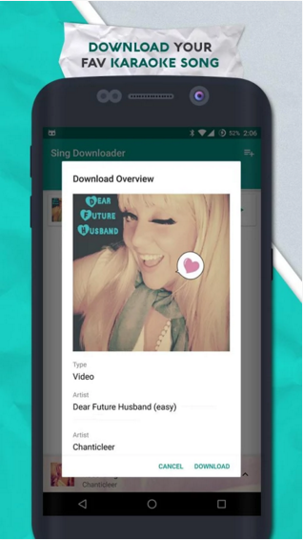
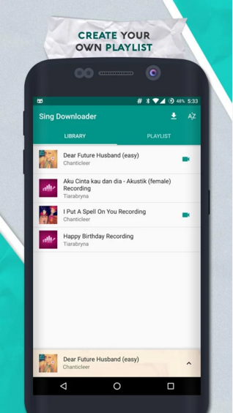
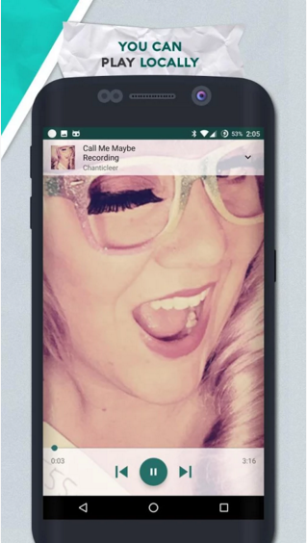

Ngobrol
Free messaging and voice call app highly integrated with Google Services and other open-source APIs and libraries. Using GCM (Google Cloud Messaging) as push technology as the highest dependency to exchange messages, while Sinch service is responsible for voice calling feature. Main feature of Ngobrol is the decision not to keep text-based chat records in server, therefore not only ensures users’ privacy, but also lightweight to server. Although still in beta channel, this particular app has brought me a nominee in INAICTA 2015, while also abusively used as a research in my undergraduate degree thesis.
https://play.google.com/store/apps/details?id=com.ngobrol.app
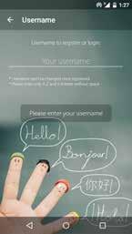
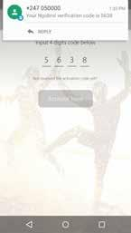
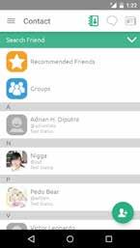
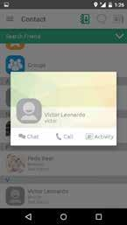
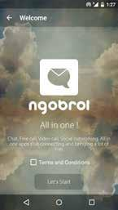
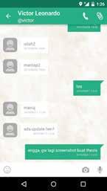

SIMPLIFY-INC
Official marketing app from PT. Simplinc Tri Jaya
https://play.google.com/store/apps/details?id=com.simplify_inc.indonesia
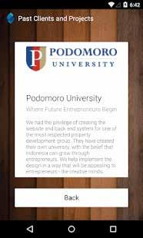



Night Butterfly
Troublesome side project from PT. Simplinc Tri Jaya, Night Butterfly is like an encyclopedia for underground entertainment all around Jakarta. Although some venues listed in this app have repeatedly requested to take down this app, board members of Simplinc Tri Jaya have decided to release this app anyway. I no longer maintain the project.
https://play.google.com/store/apps/details?id=com.simplifyinc.nightbutterfly

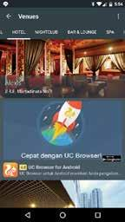
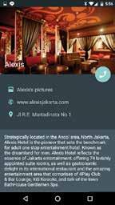

Offset Printing Manager
Desktop software that was originally developed for personal business use. After almost 2 years of operating, receiving feedbacks from numerous volunteers, and patching, this software now runs on some offset printing businesses in my environment.
